ACKNOWLEDGEMENT

We have taken efforts in this project. However, it would not have been possible without the kind support and help of many individuals. We would like to extend our sincere thanks to all of them.
The project is a group project as per the first part of the second year Object Oriented Programming Course of IOE, Pulchowk Campus. Although this project is a team task, it wouldn't have been completed so far without the support and principal guidelines of the teachers who have absolutely shown their passion in helping us during the theory sessions and practical works. In this account, we would like to express my sincere appreciation towards the department of Electronics and Computer Engineering for providing us, students, the golden opportunity for gratify ourselves in the practical application and enlightening us with the theory and helping us understand and embrace the concepts of Object Oriented Programming. Any project of this quality would not have been attained without the proper guidance and instruction.
We are highly obligated to Mr.Bashanta Joshi and the lab teachers for their guidance, counseling and constant supervision .Not only this they also helped by providing necessary information regarding the project and also for their support in completing the project. In this regard, we would also like to thank Department of Electronics and Computer Engineering in giving us the golden opportunity to keep implement our ideas and to incorporate the things we have learnt in the best way we can, which will also help us in doing a lot of Research and to know about many new things.
We are in all humbleness and gratefulness to acknowledge our depth to all those who have helped us to put these ideas, well above the level of simplicity and into something effective. Any attempt at any level can’t be agreeable completed without the support and guidance of our parents and friends.
Our thanks and appreciations also go to our colleague who helped us in developing this project and people who have willingly helped us out.
Any suggestions for the improvement of the project will be highly appreciated.

073BEX402 Alex Bhattarai 073bex402.alex@pcampus.edu.np
073BEX425 Prashant Bhatta 073bex425.prashant@pcampus.edu.np
073BEX441 Pravesh Gaire 073bex427.pravesh@pcampus.edu.np
073BEX441 Shishir Panta 073bex441.shishir@pcampus.edu.np

ABSTRACT

The “Locenger” is a messaging application as a part of our bachelor second year first part object oriented programming project. In this we initially have to run a server for the main clients to run and connect to other clients. The program GUI is made using gtkmm-3.0, and sockets are used from internal C header files of linux, need a linux OS to run the program.
After the file server.cpp is run then we can launch our application by running the main program. After the main program starts to run then a window appears asking us to open the messenger box. After we click the block Open then another window appears that asks us to input our username and password. If we put the password correctly then next window displaying message Login successful appears else message Login not successful is displayed. After we have successfully login then we need to press the OK button to continue. After we press the OK button another window i.e Chat window appears and from the chat window we can send messages to other clients connected on the same server. The message sent and received is displayed in the Chat box.
We have used gtx library to make the graphical user interface. The options available to us are:
Send message in the group chat.
Receive messages sent by other clients.
Clear the window if we don’t want to see previous messages.
Add files box is added but the feature is not accessible as of now due to lack of time.
Exit the group chat if we want to.

TABLE OF CONTENTS

ACKNOWLEDGEMENT i

ABSTRACT ii

TABLE OF CONTENT iii

INTRODUCTION 1-2

Background 1

Problem Statement 1
Objectives…………………………………………………………………………………1
Scope and Application……………………………………………………………………2

THEORITICAL BACKGROUND

555 Timer IC

Modes of Operation of 555 Timer IC

Operating the 555 Timer IC in Astable Mode for the Traffic Light System……………

7805 Voltage Regulator

BC547 Transistor

Resistors

Surface Mount Resistor

Capacitor

Potentiometer
PCB………………………………………………………………………………………
Processes Involved………………………………………………………………………

Schematic Capture

PCB Layout

PCB Printing and Ironing
Itching, Cleansing and Drilling

Soldering

METHODOLOGY
Circuit Interpretation with Block Diagram

Block Wise Explanation
Proteus Diagram……………………………………………………………………….
Circuit Description and Diagram………………………………………………………

Equipment and Components Required

Circuit Diagram from KIKAD

PCB Design

CONCLUSION

Project Conclusion

Limitations
Future Enhancements……………………………………………………………………
Recommendations……………………………………………………………………….

REFERENCES
APPENDIX………………………………………………………………………………………

1. INTRODUCTION

1.1. Background
Basically as a part of OOP project our team has made a Chat app that can be used to send and receive messages. For this the clients need to be on the same server and instead of individual messaging facility we have incorporated the group message facility.
We have prepared this application on UNIX OS as the features of ‘Socket Programming’ were easily accessible and usable in UNIX based operating systems. We have used header files i.e. preprocessor directives that are made for C programs and also valid in C++ programs.
Basically our project revolves around the concept of a client and server where server awaits for connection to be established and the clients request for making connection. After the connection is made then the data can be exchanged in between server and the connected client. Even multiple clients can connect to the server and exchange data between them at the same time. To make our application more user friendly we have also included GUI that right now does not accept logins but works with username and password fed in the code.
The below diagram gives a basic idea of the server/client relationship.
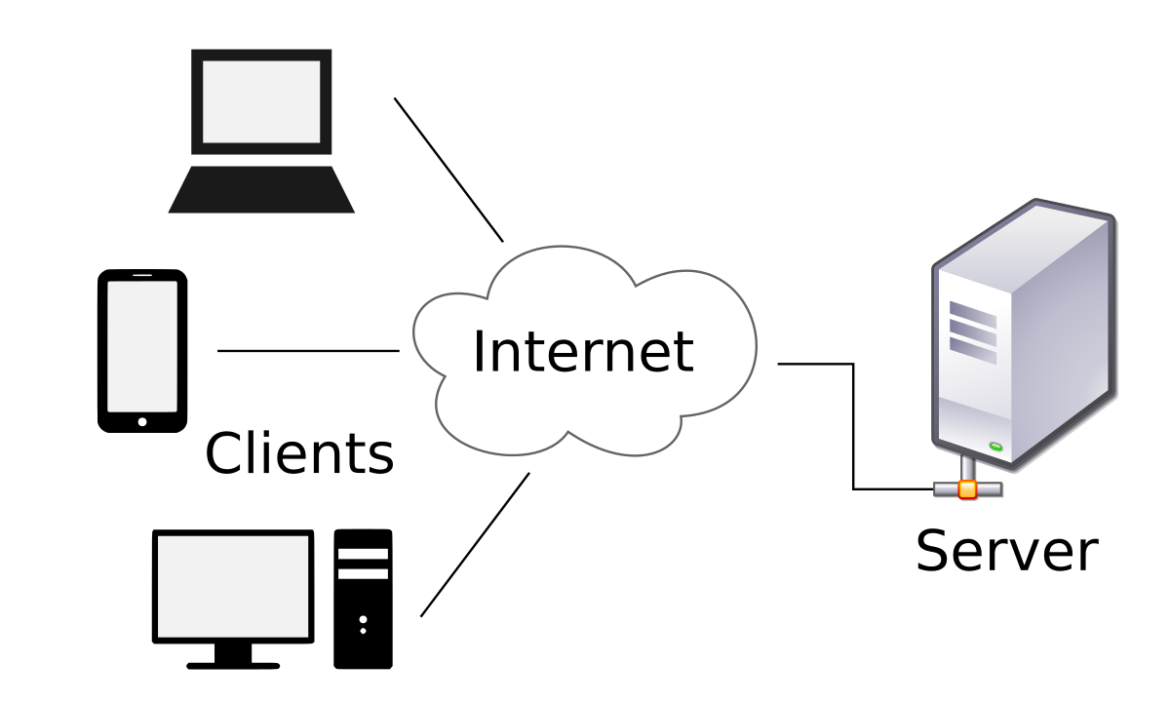
Source: https://en.wikipedia.org/wiki/Client%E2%80%93server_model

1.2. Problem Statement
As a part of OOP project we are to develop an application or a program using any libraries valid in C++ programming language and include in it the basic and important concepts of Object Oriented Programming such as Polymorphism, Classes and Objects, Inheritance, Operator Overloading, File Handling, etc.

1.3. Objectives
- To use the concept of Object Oriented Programming into our project using C++.
- To be able to use and understand bottom to top approach of the Object Oriented Programming.
- To be able to concatenate command line interface and graphical user interface to create a user friendly Chat application.
- To be able to work in cohesion on a group project solving problems through discussion and to complete the project on time by proper distribution of workloads.
- To be familiar with how network programming works, what socket programming is and the server-client relationship in networking.
- To be familiar with using Linux Operating System, its terminal operation, its GNOME, its commands.
- To allow several clients to share data with each other by connecting to the same server.

1.4. Scope and Application
Our Chat application has great application in real life as it can be extended to exchanging messages not only between a group of clients but between two clients as well. This app is not limited to exchanging messages but can also be extended to exchanging files and even video and audio calls if we use UDP (User Datagram Protocol).
Also if a group of people want to stay out of internet and still exchange messages and files then our Chat app makes it possible. All one needs to do is set up a server by generating Hotspot or even using LAN cable and then the clients can connect to the server and exchange messages they want to.

2. THEORITICAL BACKGROUND
Socket programming is a way of connecting two nodes on a network to communicate with each other. One socket(node) listens on a particular port at an IP, while other socket reaches out to the other to form a connection. Server forms the listener socket while client reaches out to the server.

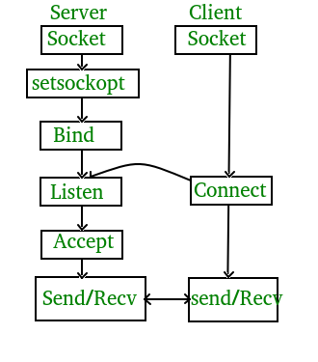
Server Socket
- create a socket - Get the file descriptor!
- bind to an address -What port am I on?
- listen on a port, and wait for a connection to be established.
- accept the connection from a client.
- send/recv - the same way we read and write for a file.
- shutdown to end read/write.
- close to releases data.
Client Socket
- create a socket.
- bind* - this is probably be unnecessary because you're the client, not the server.
- connect to a server.
- send/recv - repeat until we have or receive data
- shutdown to end read/write.
- close to releases data.

Connection
A relationship between two machines, where two pieces of software know about each other. Those two pieces of software know how to communicate with each other. In other words, they know how to send bits to each other.
A socket connection means the two machines have information about each other, including network location (IP address) and TCP port. (If we can use anology, IP address is the phone number and the TCP port is the extension).
A socket is an object similar to a file that allows a program to accept incoming connections, make outgoing connections, and send and receive data. Before two machines can communicate, both must create a socket object.
A socket is a resource assigned to the server process. The server creates it using the system call socket(), and it can't be shared with other processes.

TCP vs UDP
There are several different types of socket that determine the structure of the transport layer. The most common types are stream sockets and datagram sockets.
Stream Sockets
Stream sockets provide reliable two-way communication similar to when we call someone on the phone. One side initiates the connection to the other, and after the connection is established, either side can communicate to the other.
In addition, there is immediate confirmation that what we said actually reached its destination.
Stream sockets use a Transmission Control Protocol (TCP), which exists on the transport layer of the Open Systems Interconnection (OSI) model. The data is usually transmitted in packets. TCP is designed so that the packets of data will arrive without errors and in sequence.
Webservers, mail servers, and their respective client applications all use TCP and stream socket to communicate.
Datagram Sockets
Communicating with a datagram socket is more like mailing a letter than making a phone call. The connection is one-way only and unreliable.
If we mail several letters, we can't be sure that they arrive in the same order, or even that they reached their destination at all. Datagram sockets use User Datagram Protocol (UDP). Actually, it's not a real connection, just a basic method for sending data from one point to another.
Datagram sockets and UDP are commonly used in networked games and streaming media.
Though in this section, we mainly put focus on applications that maintain connections to their clients, using connection-oriented TCP, there are cases where the overhead of establishing and maintaining a socket connection is unnecessary.
For example, just to get the data, a process of creating a socket, making a connection, reading a single response, and closing the connection, is just too much. In this case, we use UDP.
Services provided by UDP are typically used where a client needs to make a short query of a server and expects a single short response. To access a service from UDP, we need to use the UDP specific system calls, sendto() and recvfrom() instead of read() and write() on the socket.
UDP is used by app that doesn't want reliability or bytestreams.
  - Voice-over-ip (unreliable) such as conference call. (visit VoIP)
  - DNS, RPC (message-oriented)
  - DHCP (bootstrapping)

Client/Server
The client-server model distinguishes between applications as well as devices. Network clients make requests to a server by sending messages, and servers respond to their clients by acting on each request and returning results.
For example, let's talk about telnet.
When we connect to a remote host on port 23 with telnet (the client), a program on that host (called telnetd, the server) springs to life. It handles the incoming telnet connection, sets us up with a login prompt, etc.
One server generally supports numerous clients, and multiple servers can be networked together in a pool to handle the increased processing load as the number of clients grows.
Some of the most popular applications on the Internet follow the client-server model including email, FTP and Web services. Each of these clients features a user interface and a client application that allows the user to connect to servers. In the case of email and FTP, users enter a computer name (or an IP address) into the interface to set up connections to the server.
The steps to establish a socket on the server side are:
- Create a socket with the socket() system call.
- The server process gives the socket a name. In linux file system, local sockets are given a filename, under /tmp or /usr/tmp directory. For network sockets, the filename will be a service identifier, port number, to which the clients can make connection. This identifier allows to route incoming connections (which has that the port number) to connect server process. A socket is named using bind() system call.
- The server process then waits for a client to connect to the named socket, which is basically listening for connections with the listen() system call. If there are more than one client are trying to make connections, the listen() system call make a queue.
The machine receiving the connection (the server) must bind its socket object to a known port number. A port is a 16-bit number in the range 0-65535 that's managed by the operating system and used by clients to uniquely identify servers. Ports 0-1023 are reserved by the system and used by common network protocols.
- Accept a connection with the accept() system call. At accept(), a new socket is created that is distinct from the named socket. This new socket is used solely for communication with this particular client.
For TCP servers, the socket object used to receive connections is not the same socket used to perform subsequent communication with the client. In particular, the accept() system call returns a new socket object that's actually used for the connection. This allows a server to manage connections from a large number of clients simultaneously.
- Send and receive data.
- The named socket remains for further connections from other clients. A typical web server can take advantage of multiple connections. In other words, it can serve pages to many clients at once. But for a simple server, further clients wait on the listen queue until the server is ready again.
The steps to establish a socket on the client side are:
- Create a socket with the socket() system call.
- Connect the socket to the address of the server using the connect() system call.
- Send and receive data. There are a number of ways to do this, but the simplest is to use the read() and write() system calls.

Network Byte Order
The port number and IP address used in the AF_INET socket address structure are expected to follow the network byte ordering (big-endian). This is the opposite of x86's little-endian byte ordering, so these values must be converted. There are specialized functions for the conversions, and they are defined in netinet.h and arpa/inet.h.
"Basically, we want to convert the numbers to Network Byte Order before they go out on the wire, and convert them to Host Byte Order as they come in off the wire."
- htonl (long value) Host-to-Network Long
Converts a 32-bit integer from the host's byte order to network byte order.
- htons (short value) Host-to-Network Short
Converts a 16-bit integer from the host's byte order to network byte order.
- ntohl (long value) Network-to-Host Long
Converts a 32-bit integer from network byte order to the host's byte order.
- ntohs (short value) Network-to-Host Short
Converts a 16-bit integer from network byte order to the host's byte order.
Internet Address Conversion
- inet_aton (char *ascii_addr, struct in_addr *network_addr) ASCII-to-Network
Converts an ASCII string containing IP address in dotted-number format into an in_addr, which only contains a 32-bit integer representing the IP address in network byte order.
- inet_ntoa (struct in_addr *network_addr) Network to ASCII
It is passed a pointer to an in_addr structure containing an IP address, and the function returns a character pointer to an ASCII string containing the IP address in dotted-number format. This string is held in a statically allocated memory buffer in the function, so it can be accessed until the next call to inet_ntoa(), and the string will be overwritten.

TCP Connection establishment: Three-way-handshake
To establish a connection, TCP uses a three-way handshake. Before a client attempts to connect with a server, the server must first bind to and listen at a port to open it up for connections: this is called a passive open. Once the passive open is established, a client may initiate an active open.
In other words, before communication begins, TCP establishes a new connection using a three-way handshake. This is because
- Both sender and receiver must be ready before data transport starts, and they need to agree on set of parameters such as the Maximum Segment Size (MSS).
- TCP end points maintain state about communications in both directions, and the handshake allows the state to be created and initialized.
- TCP establishes a stream of bytes in both directions, and the three-way handshake allows both streams to be established and acknowledged.
To establish a connection, the three-way handshake occurs:
- SYN: The active open is performed by the client sending a SYN to the server.
- SYN-ACK: In response, the server replies with a SYN-ACK.
- ACK: Finally, the client sends an ACK back to the server.
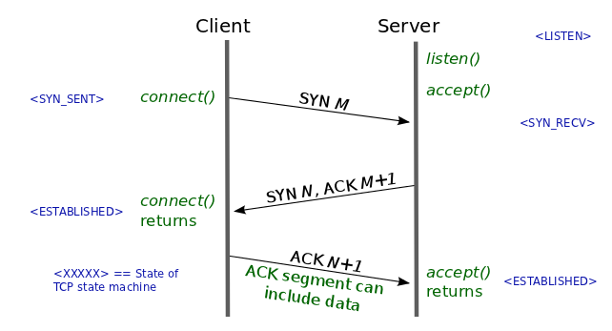

Blocking socket vs non-blocking socket
By default, TCP socket is set as blocking (sleeping) mode.
What does it mean blocking? Well, we're doing communication. We do something, and wait for the response. So, until we get the response, we cannot do anything. Just wait... and wait. What's the response? It could be either normal message or error.
For example, client did call receive() to remote server to read from a stream, control isn't returned to our program until at least one byte of data is read from the remote site. We can call this waiting process as blocking. If we use recv() in non-blocking mode by setting a descriptor as such, it will return any data that the system has in it's read buffer for that socket. But, it won't wait for that data.
Among the socket APIs we used, accept(), connect(), recv(), and recvfrom() are blocking functions.
By setting a socket to non-blocking, we can poll the socket for information. If we try to read from a non-blocking socket and there's no data there, it's not allowed to block-it will return -1 and errno will be set to EWOULDBLOCK. The non-blocking mode is set by changing one of the socket's flags.
The flags are a series of bits, each one representing a different capability of the socket.

Main Functions involved in Socket Programming
a. Sockets
Allocate a socket descriptor
Prototypes
#include <sys/types.h>
#include <sys/socket.h>
int socket(int domain, int type, int protocol);
Description
Returns a new socket descriptor that you can use to do sockety things with. This is generally the first call in the whopping process of writing a socket program, and you can use the result for subsequent calls to listen(), bind(), accept(), or a variety of other functions. In usual usage, you get the values for these parameters from a call to getaddrinfo(), as shown in the example below. But you can fill them in by hand if you really want to. domain domain describes what kind of socket you're interested in. This can, believe me, be a wide variety of things, but since this is a socket guide, it's going to be PF_INET for IPv4, and PF_INET6 for IPv6. type Also, the type parameter can be a number of things, but you'll probably be setting it to either SOCK_STREAM for reliable TCP sockets (send(), recv()) or SOCK_DGRAM for unreliable fast UDP sockets (sendto(), recvfrom().) (Another interesting socket type is SOCK_RAW which can be used to construct packets by hand. It's pretty cool.) protocol Finally, the protocol parameter tells which protocol to use with a certain socket type. Like I've already said, for instance, SOCK_STREAM uses TCP. Fortunately for you, when using SOCK_STREAM or SOCK_DGRAM, you can just set the protocol to 0, and it'll use the proper protocol automatically. Otherwise, you can use getprotobyname() to look up the proper protocol number.
domain
domain describes what kind of socket you're interested in. This can, believe me, be a wide variety of things, but since this is a socket guide, it's going to be PF_INET for IPv4, and PF_INET6 for IPv6.
type
Also, the type parameter can be a number of things, but you'll probably be setting it to either SOCK_STREAM for reliable TCP sockets (send(), recv()) or SOCK_DGRAM for unreliable fast UDP sockets (sendto(), recvfrom().) (Another interesting socket type is SOCK_RAW which can be used to construct packets by hand. It's pretty cool.)
protocol
Finally, the protocol parameter tells which protocol to use with a certain socket type. Like I've already said, for instance, SOCK_STREAM uses TCP. Fortunately for you, when using SOCK_STREAM or SOCK_DGRAM, you can just set the protocol to 0, and it'll use the proper protocol automatically. Otherwise, you can use getprotobyname() to look up the proper protocol number
Return Value
The new socket descriptor to be used in subsequent calls, or -1 on error (and errno will be set accordingly.)
Example
struct addrinfo hints, *res; int sockfd; // first, load up address structs with getaddrinfo():
memset(&hints, 0, sizeof hints);
hints.ai_family = AF_UNSPEC; // AF_INET, AF_INET6, or AF_UNSPEC
hints.ai_socktype = SOCK_STREAM; // SOCK_STREAM or SOCK_DGRAM getaddrinfo("www.example.com", "3490", &hints, &res);
// make a socket using the information gleaned from getaddrinfo():
sockfd = socket(res->ai_family, res->ai_socktype, res->ai_protocol);
b. Bind
Associate a socket with an IP address and port number
Prototypes
#include <sys/types.h>
#include <sys/socket.h>
int bind(int sockfd, struct sockaddr *my_addr, socklen_t addrlen);
Description
When a remote machine wants to connect to your server program, it needs two pieces of information: the IP address and the port number. The bind() call allows you to do just that. First, you call getaddrinfo() to load up a struct sockaddr with the destination address and port information. Then you call socket() to get a socket descriptor, and then you pass the socket and address into bind(), and the IP address and port are magically (using actual magic) bound to the socket! If you don't know your IP address, or you know you only have one IP address on the machine, or you don't care which of the machine's IP addresses is used, you can simply pass the AI_PASSIVE flag in the hints parameter to getaddrinfo(). What this does is fill in the IP address part of the struct sockaddr with a special value that tells bind() that it should automatically fill in this host's IP address. What what? What special value is loaded into the struct sockaddr's IP address to cause it to auto-fill the address with the current host? I'll tell you, but keep in mind this is only if you're filling out the struct sockaddr by hand; if not, use the results from getaddrinfo(), as per above. In IPv4, the sin_addr.s_addr field of the struct sockaddr_in structure is set to INADDR_ANY. In IPv6, the sin6_addr field of the struct sockaddr_in6 structure is assigned into from the global variable in6addr_any. Or, if you're declaring a new struct in6_addr, you can initialize it to IN6ADDR_ANY_INIT. Lastly, the addrlen parameter should be set to sizeof my_addr.
Return
Value Returns zero on success, or -1 on error (and errno will be set accordingly.)
Example
// modern way of doing things with getaddrinfo()
struct addrinfo hints, *res; int sockfd;
// first, load up address structs with getaddrinfo():
memset(&hints, 0, sizeof hints);
hints.ai_family = AF_UNSPEC; // use IPv4 or IPv6, whichever
hints.ai_socktype = SOCK_STREAM;
hints.ai_flags = AI_PASSIVE; // fill in my IP for me
getaddrinfo(NULL, "3490", &hints, &res);
// make a socket: // (you should actually walk the "res" linked list and error-check!)
sockfd = socket(res->ai_family, res->ai_socktype, res->ai_protocol);
// bind it to the port we passed in to getaddrinfo():
bind(sockfd, res->ai_addr, res->ai_addrlen);
// example of packing a struct by hand, IPv4
struct sockaddr_in myaddr;
int s;
myaddr.sin_family = AF_INET;
myaddr.sin_port = htons(3490);
// you can specify an IP address:
inet_pton(AF_INET, "63.161.169.137", &(myaddr.sin_addr));
// or you can let it automatically select one:
myaddr.sin_addr.s_addr = INADDR_ANY;
s = socket(PF_INET, SOCK_STREAM, 0);
bind(s, (struct sockaddr*)&myaddr, sizeof myaddr);
c. Listen
Tell a socket to listen for incoming connections
Prototypes
#include<sys/socket.h>
int listen(int s, int backlog);
Description
You can take your socket descriptor (made with the socket() system call) and tell it to listen for incoming connections. This is what differentiates the servers from the clients. The backlog parameter can mean a couple different things depending on the system you on, but loosely it is how many pending connections you can have before the kernel starts rejecting new ones. So as the new connections come in, we should be quick to accept() them so that the backlog doesn't fill. Before calling listen(), server should call bind() to attach itself to a specific port number. That port number (on the server's IP address) will be the one that clients connect to.
Return Value
Returns zero on success, or -1 on error (and errno will be set accordingly.)
Example
struct addrinfo hints, *res;
int sockfd; // first, load up address structs with getaddrinfo():
memset(&hints, 0, sizeof hints);
hints.ai_family = AF_UNSPEC; // use IPv4 or IPv6, whichever
hints.ai_socktype = SOCK_STREAM;
hints.ai_flags = AI_PASSIVE; // fill in my IP for me
getaddrinfo(NULL, "3490", &hints, &res);
// make a socket:
sockfd = socket(res->ai_family, res->ai_socktype, res->ai_protocol); /
/ bind it to the port we passed in to getaddrinfo():
bind(sockfd, res->ai_addr, res->ai_addrlen);
listen(sockfd, 10); // set s up to be a server (listening) socket
// then have an accept() loop down here somewhere
d. Accept
Accept an incoming connection on a listening socket
Prototypes
#include <sys/types.h>
#include <sys/socket.h>
int accept(int s, struct sockaddr *addr, socklen_t *addrlen);
Description
Once we got a SOCK_STREAM socket and set it up for incoming connections with listen(), then we call accept() to actually get ourself a new socket descriptor to use for subsequent communication with the newly connected client. The old socket that we are using for listening is still there, and will be used for further accept() calls as they come in.
s
The listen()ing socket descriptor.
addr
This is filled in with the address of the site that's connecting to us.
addrlen
This is filled in with the sizeof() the structure returned in the addr parameter.
accept() will normally block, and we can use select() to peek on the listening socket descriptor ahead of time to see if it's “ready to read”. If so, then there's a new connection waiting to be accept()ed! Alternatively, we could set the O_NONBLOCK flag on the listening socket using fcntl(), and then it will never block, choosing instead to return -1 with errno set to EWOULDBLOCK. The socket descriptor returned by accept() is a bona fide socket descriptor, open and connected to the remote host. We have to close() it when we're done with it.
Return Value
accept() returns the newly connected socket descriptor, or -1 on error, with errno set appropriately.
Example
struct sockaddr_storage their_addr;
socklen_t addr_size;
struct addrinfo hints, *res;
int sockfd, new_fd;
// first, load up address structs with getaddrinfo():
memset(&hints, 0, sizeof hints);
hints.ai_family = AF_UNSPEC; // use IPv4 or IPv6, whichever
hints.ai_socktype = SOCK_STREAM;
hints.ai_flags = AI_PASSIVE; // fill in my IP for me
getaddrinfo(NULL, MYPORT, &hints, &res);
// make a socket, bind it, and listen on it:
sockfd = socket(res->ai_family, res->ai_socktype, res->ai_protocol);
bind(sockfd, res->ai_addr, res->ai_addrlen);
listen(sockfd, BACKLOG);
// now accept an incoming connection:
addr_size = sizeof their_addr;
new_fd = accept(sockfd, (struct sockaddr *)&their_addr, &addr_size);
// ready to communicate on socket descriptor new_fd!
e. Connect
Connect a socket to a server
Prototypes
#include <sys/socket.h>
#include <sys/types.h>
int connect(int sockfd, const struct sockaddr *serv_addr, socklen_t addrlen);
Description
Once we've built a socket descriptor with the socket() call, you can connect() that socket to a remote server using the well-named connect() system call. All we need to do is pass it the socket descriptor and the address of the server you're interested in getting to know better. (Oh, and the length of the address, which is commonly passed to functions like this.) Usually this information comes along as the result of a call to getaddrinfo(), but we can fill out our own struct sockaddr if we want to. If we haven't yet called bind() on the socket descriptor, it is automatically bound to our IP address and a random local port. This is usually just fine with us if we're not a server, since we really don't care what our local port is; we only care what the remote port is so we can put it in the serv_addr parameter. We can call bind() if we really want your client socket to be on a specific IP address and port, but this is pretty rare. Once the socket is connect()ed, we’re free to send() and recv() data on it to our heart's content.
Return Value
Returns zero on success, or -1 on error (and errno will be set accordingly.)
Example
// connect to www.example.com port 80 (http)
struct addrinfo hints, *res;
int sockfd;
// first, load up address structs with getaddrinfo():
memset(&hints, 0, sizeof hints);
hints.ai_family = AF_UNSPEC; // use IPv4 or IPv6, whichever
hints.ai_socktype = SOCK_STREAM;
// we could put "80" instead on "http" on the next line:
getaddrinfo("www.example.com", "http", &hints, &res);
// make a socket:
sockfd = socket(res->ai_family, res->ai_socktype, res->ai_protocol);
// connect it to the address and port we passed in to getaddrinfo():
connect(sockfd, res->ai_addr, res->ai_addrlen);
f. recv
Receive data on a socket
Prototypes
#include <sys/socke.h>
#include <sys/types.h>
ssize_t recv(int s, void *buf, size_t len, int flags);
ssize_t recvfrom(int s, void *buf, size_t len, int flags, struct sockaddr *from, socklen_t *fromlen);
Description
Once we have a socket up and connected, we can read incoming data from the remote side using the recv() (for TCP SOCK_STREAM sockets). It take the socket descriptor s, a pointer to the buffer buf, the size (in bytes) of the buffer len, and a set of flags that control how the functions work. When we call recv(), it will block until there is some data to read. If we want to not block, set the socket to non-blocking or check with select() or poll() to see if there is incoming data before calling recv().
Return Value
Returns the number of bytes actually received (which might be less than you requested in the len parameter), or -1 on error (and errno will be set accordingly.) If the remote side has closed the connection, recv() will return 0.
g. send()
Send data out over a socket
Prototypes
#include <sys/types.h>
#include <sys/socket.h>
ssize_t send(int s, const void *buf, size_t len, int flags);
ssize_t sendto(int s, const void *buf, size_t len, int flags, const struct sockaddr *to, socklen_t tolen); Description
These functions send data to a socket. With send() , the parameter s is the socket, buf is a pointer to the data we want to send, len is the number of bytes we want to send, and flags allows us to specify more information about how the data is to be sent. Set flags to zero if we want it to be “normal” data.
Return Value
Returns the number of bytes actually sent, or -1 on error (and errno will be set accordingly.) Note that the number of bytes actually sent might be less than the number we asked it to send! Also, if the socket has been closed by either side, the process calling send() will get the signal SIGPIPE. (Unless send() was called with the MSG_NOSIGNAL flag.)
g. Close()
Close a socket descriptor
Prototypes
#include <unistd.h>
int close(int s);
Description After we’ve finished using the socket for whatever demented scheme we have concocted and we don't want to send() or recv() or, indeed, do anything else at all with the socket, we can close() it, and it'll be freed up, never to be used again. The remote side can tell if this happens one of two ways.
One: if the remote side calls recv(), it will return 0.
Two: if the remote side calls send(), it'll receive a signal SIGPIPE and send() will return -1 and errno will be set to EPIPE.
Return Value
Returns zero on success, or -1 on error (and errno will be set accordingly.)
Example
s = socket(PF_INET, SOCK_DGRAM, 0);
. . .
// code ….
close(s);
select()
Check if sockets descriptors are ready to read/write
Prototypes
#include <sys/select.h>
int select(int n, fd_set *readfds, fd_set *writefds, fd_set *exceptfds, struct timeval *timeout); FD_SET(int fd, fd_set *set);
FD_CLR(int fd, fd_set *set);
FD_ISSET(int fd, fd_set *set);
FD_ZERO(fd_set *set);
Description
The select() function gives us a way to simultaneously check multiple sockets to see if they have data waiting to be recv()d, or if we can send() data to them without blocking, or if some exception has occurred. We populate our sets of socket descriptors using the macros, like FD_SET(), above. Once we have the set, we pass it into the function as one of the following parameters:
readfds
if we want to know when any of the sockets in the set is ready to recv() data,
writefds
if any of the sockets is ready to send() data to, and/or
exceptfds
if we need to know when an exception (error) occurs on any of the sockets.
Any or all of these parameters can be NULL if we’re not interested in those types of events.
After select() returns, the values in the sets will be changed to show which are ready for reading or writing, and which have exceptions. The first parameter, n is the highest-numbered socket descriptor plus one. Lastly, the struct timeval, timeout, at the end—this lets us tell select() how long to check these sets for. It'll return after the timeout, or when an event occurs, whichever is first. The struct timeval has two fields: tv_sec is the number of seconds, to which is added tv_usec, the number of microseconds (1,000,000 microseconds in a second.) The helper macros do the following:
FD_SET(int fd, fd_set *set); // Add fd to the set.
FD_CLR(int fd, fd_set *set); // Remove fd from the set.
FD_ISSET(int fd, fd_set *set); // Return true if fd is in the set.
FD_ZERO(fd_set *set); // Clear all entries from the set.
Other useful functions and structures
getaddrinfo(), freeaddrinfo()
Get information about a host name and/or service and load up a struct sockaddr with the result.
Prototypes
#include <sys/types.h>
#include <sys/socket.h>
#include <sys/netdb.h>
int getaddrinfo(const char *nodename, const char *servname, const struct addrinfo *hints, struct addrinfo **res);
void freeaddrinfo(struct addrinfo *ai);
const char *gai_strerror(int ecode);
struct addrinfo
{
int ai_flags; // AI_PASSIVE, AI_CANONNAME, ...
int ai_family; // AF_xxx
int ai_socktype; // SOCK_xxx
int ai_protocol; // 0 (auto) or IPPROTO_TCP, IPPROTO_UDP
socklen_t ai_addrlen; // length of ai_addr
char *ai_canonname; // canonical name for nodename
struct sockaddr *ai_addr; // binary address
struct addrinfo *ai_next; // next structure in linked list
};

Description
getaddrinfo() is an excellent function that will return information on a particular host name (such as its IP address) and load up a struct sockaddr for us, taking care of the gritty details (like if it's IPv4 or IPv6.) It replaces the old functions gethostbyname() and getservbyname(). The whole structure is zeroed before use with memset(). Finally, when we're done with the linked list, we need to call freeaddrinfo() to free up the memory (or it will be leaked)
Return Value
Returns zero on success, or nonzero on error. If it returns nonzero, we can use the function gai_strerror() to get a printable version of the error code in the return value.
htons(), htonl(), ntohs(), ntohl()
Convert multi-byte integer types from host byte order to network byte order
htons() - host to network
short htonl() - host to network
long ntohs() - network to host
short ntohl() - network to host long
inet_ntoa(), inet_aton(), inet_addr
Convert IP addresses from a dots-and-number string to a struct in_addr and back
The function inet_ntoa() converts a network address in a struct in_addr to a dots-and-numbers format string. The “n” in “ntoa” stands for network, and the “a” stands for ASCII for historical reasons (so it's “Network To ASCII”—the “toa” suffix has an analogous friend in the C library called atoi() which converts an ASCII string to an integer.)
The function inet_aton() is the opposite, converting from a dots-and-numbers string into a in_addr_t (which is the type of the field s_addr in your struct in_addr.)
Finally, the function inet_addr() is an older function that does basically the same thing as inet_aton(). It's theoretically deprecated, but you'll see it a lot and the police won't come get you if you use it.
inet_ntop(), inet_pton()
Convert IP addresses to human-readable form and back.
Return Value
inet_ntop() returns the dst parameter on success, or NULL on failure (and errno is set). inet_pton() returns 1 on success. It returns -1 if there was an error (errno is set), or 0 if the input isn't a valid IP address.
setsockopt(), getsockopt()
Set various options for a socket
Prototypes
#include <sys/types.h>
#include <sys/socket.h>
int getsockopt(int s, int level, int optname, void *optval, socklen_t *optlen);
int setsockopt(int s, int level, int optname, const void *optval, socklen_t optlen);

3. METHODOLOGY
3.1. Flowchart
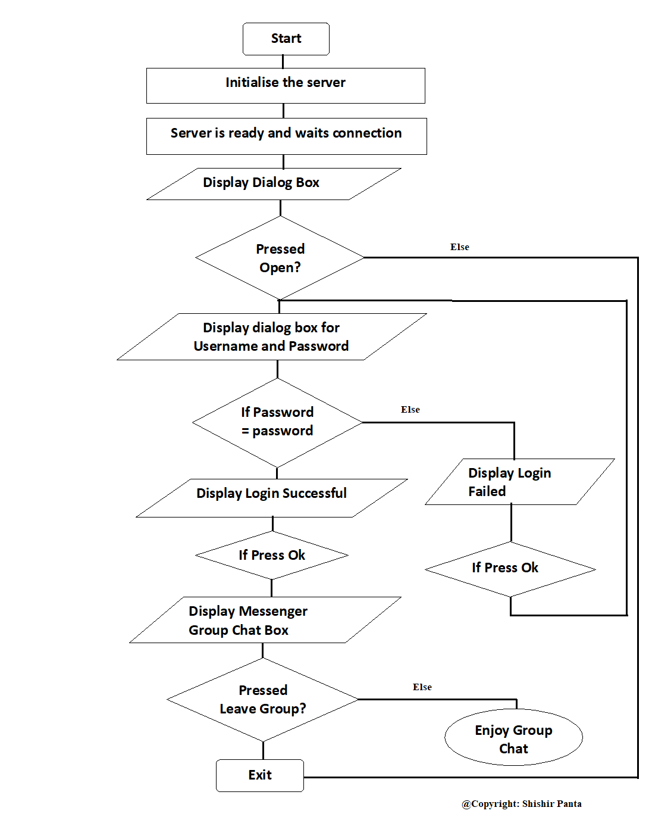
3.2. Blockwise Explanation
a. Initialize the server
In order to initialize the server we need to run the file named server.cpp from any g++ compiler. I have compiled the code in Linux using the Gnome terminal by using the command g++ server.cpp –o server. And then on another line when typed the command ./server the server is up and running.
b. Open the application
After the server has been initialize we can open the executable file to open the chat app or we can open the file directory in Gnome terminal and then type the command ./main.
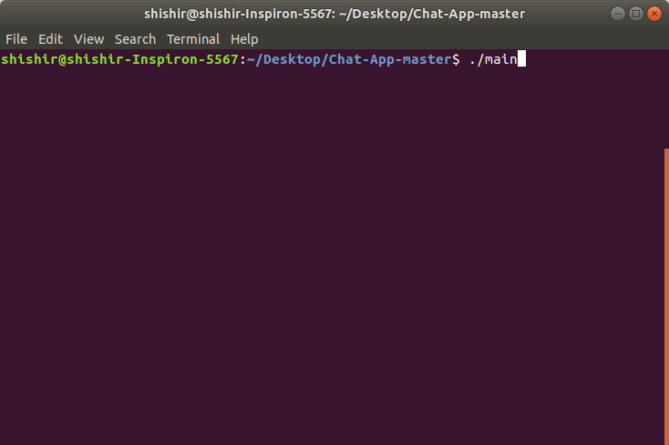
From the figure, we can see /Desktop/Chat-App-master is the file directory name. After we press return key then the following window pops up.
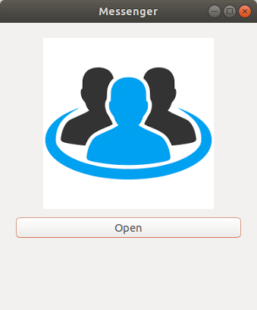

c. Pressing the `Open’ box
After the Open box is pressed then another window that asks for username and password of the user pops up.
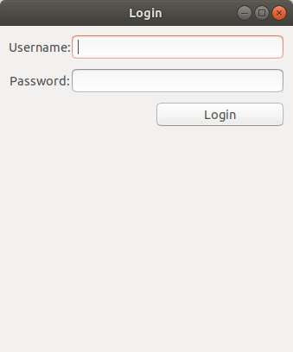
Here we can enter any username but for the moment the password to login has to be password.

d. If Password = ‘password’
If the password is entered correctly then the login successful window pops up as shown below.
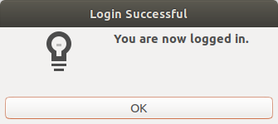

e. If Password is not password
If the password is not correctly entered we cannot access the Chat app. The journey to the chat app does not end right here and a message is displayed.
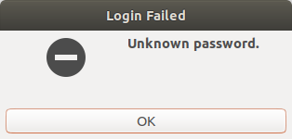

f. If Ok pressed after step 5
Then we will again be able to enter our username and password.
This box pops up again.

g. If Ok pressed after step 4
Then we will finally be able to access the chat dialog box.
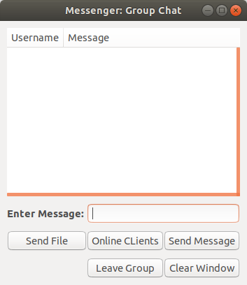

h. For multiple users (just a demo)
The following figure gives an idea how things are working in the terminal.
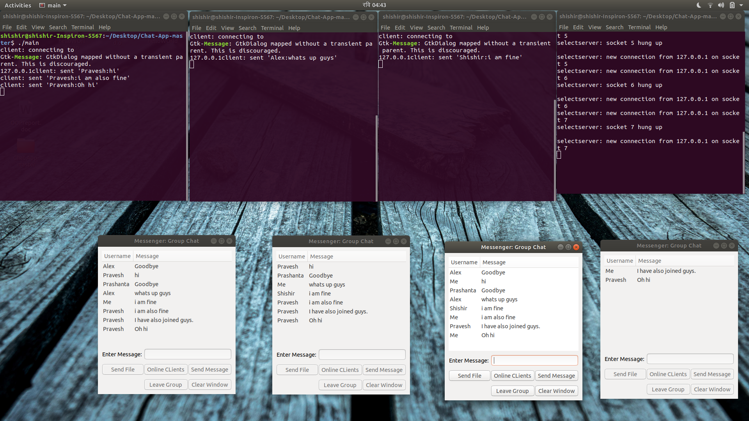

4. Implementation
“ Locenger ” - Local Messenger is a client server model chat app which can be used to send message between two or more clients. The program was written on C++ following the object oriented programming methodologies.
The server part runs continuously so as to handle the client events. The server contains a class named Server which encapsulates all the methods used to handle clients. The server doesnot have a gui implementation as can be run through the terminal. The server.hpp contains fucntion like createSocket() to create, bind and listen server socket, initSocket() fills in the necessary information of server and client to struct addrinfo and then we run a infinite loop on runServer() fucntion to handle clients. Multiple client handling is done using select() which basically stores the clients in a master set containing 3 subsets to read, write the available clients. If a client is available for writing it then writes data to it, same for receiving data, then deletes it from subset after work accomplished. The server echo’s back the received message to all the client's except the sender when normal text is sent. But when client asks to show online clients, then the server handles them differently. We have made a vector of client's information to store its file descriptor and name. The server extracts the client information and echo’s back to client. In this way server runs to give client's a platform to share messages between them.
The client part is implemented using GUI for user friendly interface. Gtkmm-3.0 is used as GUI toolkit. Gtkmm is a C++ wrapper for gtk+, a library used to create gaphical user interface. The client contains a class named Client which inherits a class named Gtk::Window in the header file gtkmm.h. It contains necessary fucntions to make a GUI. The client class contains other necessary functions like createClientSocket() to make a socket descriptor, loign() funtion which makes a GUI for login winndow, chat() function to make a chat window, and other necessary fucntions to display, send, receive and handle different gui events.
Thus a client-server chat app is made combining all the headers and .cpp files.

5. CONCLUSION
5.1. Project Conclusion
The completion of the project in itself is a Herculean feat for all of us. Initially deemed impossible due to limited time and the burden of other courseloads, we have finally completed the project through united team effort and workload distribution. Through the use of chat app we can share messages in a group. The group number may vary and depends on the number of clients connected to the network. For now we cannot share files but we surely can share text messages. Through the use of socket programming in the backend and GUI to make our application more user friendly, our application finely portrays the concepts of object oriented programming.
From this project we learned many things. Some of them are as below:
To work in a team and share ideas to complete the project through discussion, work division, goal setting for each week.
We learned the basics of Network Programming, how the server-client model works, what an IP means, how can GUI be implemented to create user friendly applications.
We learned to work under pressure and under conditions where normal people would easily give up.
We also learned about many socket functions and how they can be implemented in C++.

5.2. Limitations
A

5.3. Future enhancement
The project as of now is not a complete version of a chat app we as a team imagined before starting this project. We can add many features and options that will make the chat app more usable in real life world.
Some enhancements that are possible are:
One to one chat
Instead of making a group chat we can also extend this to making one client to next client chat. Right now any message is received by all the people who are connected on the server but we can also extend to make it possible for clients to start a one to one conversation by not involving many people.
File Transfer feature
Right now we cannot transfer any files between clients. So we can extend this feature to involve transferring of any files between users.
Video/Audio call
Instead of using TCP we can use UDP in order to make video and audio calls later in the future.
Private/ Anonymous Chat
We can also add this feature to make sure that no one can read our conversation.

5.4. Recommendations
Messaging application is used by almost over a billion people as of now. Our application is generally desirable in public and can not only be used as messaging application. We can use it in websites to make a communication between the customers and sellers and many such purposes. Our application makes communication between people in today’s world where people value communication a lot.
6. REFERENCES

13. Appendix
Source code:
- Header file
#ifndef HEADER_H
#define HEADER_H
/**
Author: Pravesh Gaire
Class client contains the methods used for graphics implemented using gtkmm-3.0 and socket implemented in linux
Works on Ubuntu provided that gtkmm is installed
*/
#include<gtkmm.h>
#include<iostream> //cout
#include<string> //string
#include<sys/socket.h> //socket
#include<arpa/inet.h> //inet_addr
#include<netdb.h> //hostent
#include<unistd.h>
#include <errno.h>
#include <sys/types.h>
#include <netinet/in.h>
//#include"client.cpp"
using namespace std;

class Client:public Gtk::Window
{
private:
Gtk::TreeView *treeview;
Gtk::Label *label;
Gtk::Entry *text;
Gtk::ScrolledWindow *scroll;
std::string emessage;
std::string Username;

int sockfd, numbytes;
char buf[256];
struct addrinfo hints, *servinfo, *p;
int rv;
char s[INET6_ADDRSTRLEN];
public:
Client();
bool receiveMessage();
void createClientSocket();
void *get_in_addr(struct sockaddr *);
void sendMessage(const char *);
void login();
void chat();
void on_button4_click();
void on_button3_click();
void on_button2_click();
void on_button1_click();
void showClients();
void displayText(std::string ,string );
void on_login_click(Gtk::Entry *,Gtk::Entry *);

std::string onlineClients();

class ModelColumns:public Gtk::TreeModel::ColumnRecord
{
public:
ModelColumns()
{
add(col_name);add(col_text);add(col_online);
}
Gtk::TreeModelColumn<Glib::ustring>col_name;
Gtk::TreeModelColumn<Glib::ustring>col_text;
Gtk::TreeModelColumn<Glib::ustring>col_online;
};
ModelColumns columns;
Glib::RefPtr<Gtk::ListStore>refTreeModel;

virtual ~Client(){}
};
#endif // HEADER_H

ii. Client.cpp
#include"Client.hpp"
Client::Client()
{
//set_size_request(200,200);
set_title("Messenger");
set_position(Gtk::WIN_POS_CENTER);
Gtk::Box *vbox=Gtk::manage(new Gtk::Box(Gtk::ORIENTATION_VERTICAL,0));
add(*vbox);
Gtk::Grid *grid=Gtk::manage(new Gtk::Grid);
vbox->add(*grid);
grid->set_border_width(20);
grid->set_row_spacing(10);
Gtk::Image *image=Gtk::manage(new Gtk::Image);
Gtk::Button *button=Gtk::manage(new Gtk::Button);
image->set("clients");
button->set_label("Open");
button->set_hexpand(true);
grid->attach(*image,0,0,1,1);
grid->attach(*button,0,1,1,1);
button->signal_pressed().connect(sigc::mem_fun(*this,&Client::login));
vbox->show_all();
}
void Client::createClientSocket()
{
memset(&hints, 0, sizeof hints);
hints.ai_family = AF_UNSPEC;
hints.ai_socktype = SOCK_STREAM;
/*if ((rv = getaddrinfo(argv[1],argv[2], &hints, &servinfo)) != 0)
{
cout<<"Error on getaddrinffo";
exit(1);
}*/
if ((rv = getaddrinfo("127.0.0.1","8888", &hints, &servinfo)) != 0)
{
cout<<"Error on getaddrinffo";
exit(1);
}
// loop through all the results and connect to the first we can
for(p = servinfo; p != NULL; p = p->ai_next) {
if ((sockfd = socket(p->ai_family, p->ai_socktype,
p->ai_protocol)) == -1) {
continue;
}
if (connect(sockfd, p->ai_addr, p->ai_addrlen) == -1) {
// close(sockfd);
exit(1);
}
break;
}
if (p == NULL) {
cout<<"client failed to connect";
exit(1);
}

inet_ntop(p->ai_family, get_in_addr((struct sockaddr *)p->ai_addr),
s, sizeof s);
cout<<"client: connecting to\n"<<s;
freeaddrinfo(servinfo); // all done with this structure
}
void *Client::get_in_addr(struct sockaddr *sa)
{
if (sa->sa_family == AF_INET) {
return &(((struct sockaddr_in*)sa)->sin_addr);
}
return &(((struct sockaddr_in6*)sa)->sin6_addr);
}
void Client::login()
{
//set_size_request(200,200);
//set_position(Gtk::WIN_POS_CENTER);
Glib::ListHandle<Widget*> childList = this->get_children();
Glib::ListHandle<Widget*>::iterator it = childList.begin();
while (it != childList.end())
{
Gtk::Container::remove(*(*it));
it++;
}
set_title("Login");
Gtk::Box *vbox=Gtk::manage(new Gtk::Box(Gtk::ORIENTATION_VERTICAL,0));
add(*vbox);
Gtk::Grid *grid=Gtk::manage(new Gtk::Grid);
grid->set_border_width(10);
grid->set_row_spacing(10);
vbox->add(*grid);
Gtk::Label *lusername=Gtk::manage(new Gtk::Label("Username:"));
grid->attach(*lusername,0,0,1,1);
Gtk::Label *lpassword =Gtk::manage(new Gtk::Label("Password:"));
grid->attach(*lpassword,0,1,1,1);
Gtk::Entry *eusername=Gtk::manage(new Gtk::Entry());
eusername->set_hexpand(true);
grid->attach(*eusername,1,0,2,1);
Gtk::Entry *epassword=Gtk::manage(new Gtk::Entry());
epassword->set_hexpand(true);
epassword->set_visibility(false);
grid->attach(*epassword,1,1,2,1);
Gtk::Button *blogin=Gtk::manage(new Gtk::Button("Login"));
blogin->signal_clicked().connect(sigc::bind<Gtk::Entry*,Gtk::Entry*>(sigc::mem_fun(*this,&Client::on_login_click),eusername,epassword));
grid->attach(*blogin,2,2,1,1);
vbox->show_all();
}
void Client::chat()
{
//set_size_request(800,600);
set_title("Messenger: Group Chat");
set_position(Gtk::WIN_POS_CENTER);
Gtk::Box *vbox=Gtk::manage(new Gtk::Box(Gtk::ORIENTATION_VERTICAL,0));
add(*vbox);
Gtk::Grid *grid=Gtk::manage(new Gtk::Grid);
grid->set_border_width(10);
grid->set_row_spacing(10);
vbox->add(*grid);
Gtk::TreeView *treeview=Gtk::manage(new Gtk::TreeView);
treeview->set_hexpand(true);
treeview->set_vexpand(true);
Gtk::ScrolledWindow *scroll=Gtk::manage(new Gtk::ScrolledWindow);
scroll->set_policy(Gtk::POLICY_ALWAYS, Gtk::POLICY_ALWAYS);
scroll->set_resize_mode(Gtk::ResizeMode::RESIZE_IMMEDIATE);
//(treeview->get_vadjustment(),Gtk::ORIENTATION_VERTICAL);
//scroll->set_focus_vadjustment();
scroll->add(*treeview);
grid->attach(*scroll,0,0,3,1);
refTreeModel = Gtk::ListStore::create(columns);
treeview->set_model(refTreeModel);
treeview->append_column("Username", columns.col_name);
treeview->append_column("Message", columns.col_text);
//treeview->append_column("Online", columns.col_online);
label = Gtk::manage(new Gtk::Label);
label->set_markup("<b>Enter Message: </b>");
grid->attach(*label, 0, 1, 1, 1);
text = Gtk::manage(new Gtk::Entry);
grid->attach(*text, 1, 1, 2, 1);
//Gtk::add_events(Gtk::KEY_MASK);
//signal_key_press_event().connect(sigc::mem_fun(*this, &myWindow::receiveMessage));
Gtk::Button *button1 = Gtk::manage(new Gtk::Button("Send Message"));
Gtk::Button *button2 = Gtk::manage(new Gtk::Button("Leave Group"));
Gtk::Button *button3 = Gtk::manage(new Gtk::Button("Send File"));
Gtk::Button *button4 = Gtk::manage(new Gtk::Button("Clear Window"));
Gtk::Button *button5 = Gtk::manage(new Gtk::Button("Online CLients"));
button1->signal_clicked().connect(sigc::mem_fun(*this, &Client::on_button1_click));
button2->signal_clicked().connect(sigc::mem_fun(*this, &Client::on_button2_click));
button3->signal_clicked().connect(sigc::mem_fun(*this, &Client::on_button3_click));
button4->signal_clicked().connect(sigc::mem_fun(*this, &Client::on_button4_click));
button5->signal_clicked().connect(sigc::mem_fun(*this, &Client::showClients));
Glib::signal_timeout().connect( sigc::mem_fun(*this, &Client::receiveMessage),50 );

grid->attach(*button1, 2, 2, 1, 1);
grid->attach(*button5, 1, 2, 1, 1);
grid->attach(*button3, 0, 2, 1, 1);
grid->attach(*button2, 1, 3, 1, 1);
grid->attach(*button4, 2, 3, 1, 1);
vbox->show_all();
// Glib::signal_idle().connect( sigc::mem_fun(*this, &myWindow::receiveMessage) );
// Glib::signal_timeout().connect((sigc::mem_fun(*this,)))
//guint g_timeout_add(10,receiveMessage,NULL);
//receiveMessage();
}
void Client::sendMessage(const char *buffer)
{
//buffer=sm.c_str();
if ((numbytes = send(sockfd, buffer, 255, 0)) == -1) {
perror("recv");
exit(1);
}
//buffer[numbytes] = '\0';
printf("client: sent '%s'\n",buffer);
}
bool Client::receiveMessage()
{
while(recv(sockfd, buf, 255, MSG_DONTWAIT) >0){
//exit(1);
int pos=string(buf).find(":");
//cout<<buf<<endl;
displayText(string(buf).substr(0,pos),string(buf).substr(pos+1));
}
return true;
}
void Client::on_login_click(Gtk::Entry *euname,Gtk::Entry *epword)
{
Username=euname->get_text();
if(epword->get_text().compare("password")==0)
{
Gtk::MessageDialog dlg("You are now logged in.",false,Gtk::MESSAGE_INFO,Gtk::BUTTONS_OK,true);
//gtk_window_set_modal(dlg,true);
dlg.set_title("Login Successful");
dlg.run();
Glib::ListHandle<Widget*> childList = this->get_children();
Glib::ListHandle<Widget*>::iterator it = childList.begin();
while (it != childList.end())
{
Gtk::Container::remove(*(*it));
it++;
}
chat();
}
else
{
Gtk::MessageDialog dlg("Unknown password.", false, Gtk::MESSAGE_ERROR, Gtk::BUTTONS_OK, true);
dlg.set_title("Login Failed");
dlg.run();
}
}
void Client::on_button4_click()
{
refTreeModel->clear();
}
void Client::on_button3_click()
{
//treeview->
//Gtk::TreeViewColumn::clear() ;
// displayText(Username," sent a file.");
}
void Client::on_button2_click()
{
//displayText("mitesh","hi hows there");
//exit(1);
displayText(Username,"Goodbye");
hide();
}
void Client::on_button1_click()
{
if(text->get_text_length() == 0)
label->set_markup("<span color='red'>Enter Message: </span>");
else
{
label->set_markup("<span color='black'>Enter Message: </span>");
emessage=text->get_text();
emessage=Username+":"+emessage;
//sendMessage(emessage);
//displayText(Username,emessage);
//Gtk::ListStore::clear();
sendMessage(emessage.c_str());
displayText("Me",text->get_text());
text->set_text("");
//receiveMessage();
}
}
std::string Client::onlineClients()
{
return "Pravesh\nMitesh\nAmit\nAlex";
}
void Client::showClients()
{
Gtk::MessageDialog dlg(onlineClients(),false,Gtk::MESSAGE_INFO,Gtk::BUTTONS_OK,true);
dlg.set_title("Online");
dlg.run();
}

void Client::displayText(std::string User,string mesg)
{
Gtk::TreeModel::Row row = *(refTreeModel->append());
row[columns.col_name] = User;
//if(mesg.size()>50)
// mesg=mesg.substr(0,50)+"\n"+mesg.substr(50);
row[columns.col_text] = mesg;
//row[columns.col_online]=onlineClients();
}

